On behalf of MHA-NYC I am pleased to nominate Kathryn Salisbury PhD, Executive Vice President of Crisis and Behavioral Health Technologies at MHA-NYC for the Innovations in Programming Award. MHA-NYC is proud to be the first organization in the country to offer evidence-based online cognitive behavioral therapy with live telephone, text and chat supports. This innovative program, Comprehensive Internet-based Cognitive Behavioral Therapy or ciCBT for short, is offered out of MHA-NYC’s state of the art Here 2 Help Contact Center (H2H).

Long committed to improving access to behavioral health treatment and promoting mental health as a crucial part of overall wellness, under Dr. Salisbury’s leadership, MHA-NYC has effectively leveraged digital technology to advance these goals and make clinically effective services accessible to the public anywhere, anytime and in the way that it is most convenient to them.

Building on MHA-NYC’s tradition of looking for innovative solutions to meet unmet needs, Dr. Salisbury and her colleagues at MHA-NYC recognized the power of adding online cognitive behavioral therapy programs to the portfolio of our contact centers services. By making cognitive behavioral therapy available online with telephone, text and chat supports, we not only tackled the problems of delays in access to care but also the shortage of clinicians trained to deliver CBT for a range of common behavioral health conditions. Additionally, online CBT reduces barriers to care such as transportation difficulties and inconvenient appointment times. Importantly, the medium is also effective in reducing the stigma for consumers who are reluctant to seek out in-office behavioral health services.

Dr. Salisbury approached the development of MHA-NYC’s comprehensive internet-based cognitive behavior (ciCBT) therapy program by seeking out online CBT programs that are evidence-based, interactive, published in peer reviewed journals, consumer friendly and culturally and linguistically competent. Our search resulted in a partnership with Cobalt Therapeutics (acquired as a unit of Magellan Health in 2014). Cobalt offers a suite of online CBT programs that address Depression, Anxiety, Insomnia, Substance Abuse and Obsessive Compulsive Disorder, conditions that are present in 25% of all adults and make up >than 90% of behavioral health complaints.

**iHelp: Sandy Stress Relief**

In one of our first implementations of ciCBT, MHA-NYC sought funding to provide ciCBT to residents of New York of New York State who were still experiencing emotional distress as a result of Superstorm Sandy. After receiving funding Social Services Block Grant funding through the New York State Office of Alcoholism and Substance Abuse, MHA-NYC involved individuals impacted by the storm and service providers involved in the disaster recovery effort to help design a marketing campaign for the program that became known as iHelp: Sandy Stress Relief.

As a result of a successful campaign iHelp: Sandy Stress Relief enrolled 4,277 people in an iHelp: Sandy Stress Relief ciCBT program, 6% of whom accessed Spanish language versions of the programs. Thirty-two percent (32%) of the enrolled individuals signed up for the depression program , 29% for the insomnia program, 18% for the anxiety program, 12% for the substance abuse program and 9% for the program for obsessive compulsive disorder.

Individuals were able to enroll by calling the iHelp number answered by MHA-NYC’s trained contact center counselors or through the online portal illustrated in the screenshot below:

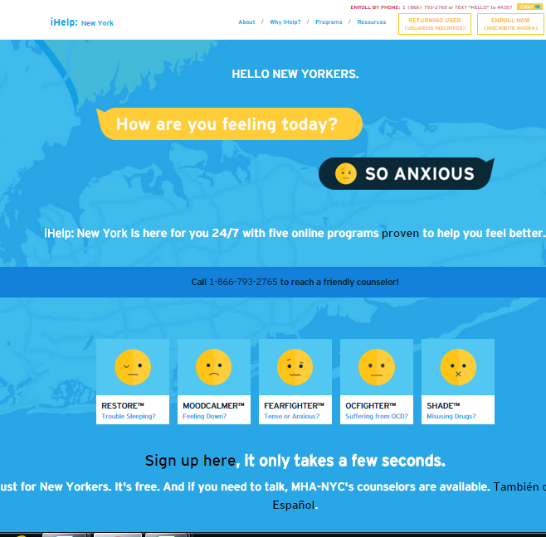

**iHelp Outcomes:**

iHelp outcome data is particularly impressive and compares favorably to in office treatment outcomes. Data collected from standardized measurement tools that were administered at baseline and follow-up showed that:

* 59% of engaged individuals across programs improved by 24%.
* 89% of individuals with severe impairment improved by 44%
* 62% of individuals with moderate impairment improved by 24%

By embedding iCBT software within MHA-NYC’s advanced and robust telephone/SMS/chat support services we have been able to:

* Create a comfortable referral process and excellent experience for users
* Provide real-time monitoring of patient progress
* Improve retention
* Provide high-quality clinical support and crisis intervention any time it’s needed
* Produce improved outcomes for enrolled individuals.

**Replicability:**

MHA-NYC has had success implementing ciCBT in other settings, including a wellness program for a Fortune 500 company with similar results. Currently, Dr. Salisbury is in the process of designing implementations of ciCBT to help Performing Provider Systems in New York City integrate behavioral health into primary care settings. ciCBT offers primary care providers a turnkey solution to integrating behavioral health into their practices and has the advantages of being rapidly scalable, instantly accessible, and has demonstrated the capacity to free up time for primary care providers to spend time with other patients. Importantly, the instant accessible of iCBT solves the screening dilemma of identifying more patients in need of care than the facility has capacity to serve.

**Summary:**

MHA-NYC’s integration of wrap-around telephonic, text and chat supports with online CBT programs represents state of the art thinking supported by research of online treatment modalities. Dr. Salisbury’s leadership in bringing this program to fruition has succeeded in empowering many consumers to receive services that they otherwise might not be able to access, and to do it on their own terms. A brief biographical sketch for Kathryn Salisbury is attached.

Kimberly Williams

President

MHA-NYC

50 Broadway, 19th Floor | New York, NY 10004

T: (212) 614-5751

[kwilliams@mhaofnyc.org](mailto:kwilliams@mhaofnyc.org)